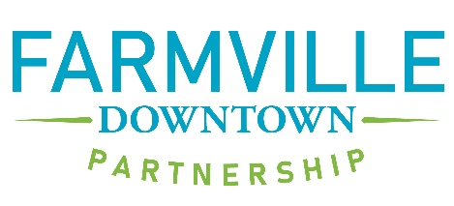
Vendor Registration Form
Rock the Block 2023 – August 26 – 6PM – 10 PM
Set up: 3:30 – 5:30 PM – all set up must be completed by 5:30 PM

Name of Organization: __________________________________________________________________________________
Address: __________________________________________________________________________________________________
Name of Contact Person: ________________________________________________________________________________
Contact Person Email Address: _________________________________________________________________________
Best Phone Number:_________________________________________________
ALL Vendors: Certificate of Insurance naming Farmville Downtown Partnership as additionally insured needs to be submitted as soon as possible. Deadline: August 11
Please describe your products or handout materials:

Vendor Space for Retailers and Community Groups : No Charge this year, but commitment MUST be made by August 4.
Farmville Downtown Partnership will provide space inside the event boundary and will promote participants at every opportunity. Farmville Downtown Partnership WILL NOT provide tables, chairs or tents.
Food Vendors: No Charge this year, but commitment MUST be made by August 4.
Price Range of items: Low ________ High ___________
Will provide items from: Food Truck __________ Trailer __________ Tent/Tables ___________
Which side of the truck/trailer will you serve from (if applicable): Left _________ Right __________
Approximate area size needed : _________________________
Will use a generator: Yes ________ No ________ Only quiet, clean running generators allowed
Electrical Needs (limited availability): 110V __________ 240V _________ None: __________
All food vendors MUST meet ALL Virginia Department of Health requirements. It is the responsibility of the food vendor to contact the local Virginia Health Department. No grease or gray water is to be poured on the ground or down any drains. Vendor will be responsible for any and all environmental cleanup cost.
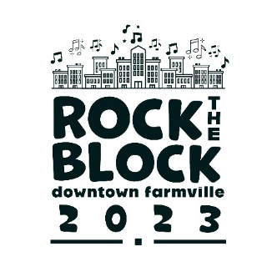
Please return the completed form to Farmville Downtown Partnership at manager@farmville downtown.com. Questions? Call Nancy Alexander at 434.392.3060.

